1-3_Lambda Overview

Sunday, August 22, 2021

10:38 AM

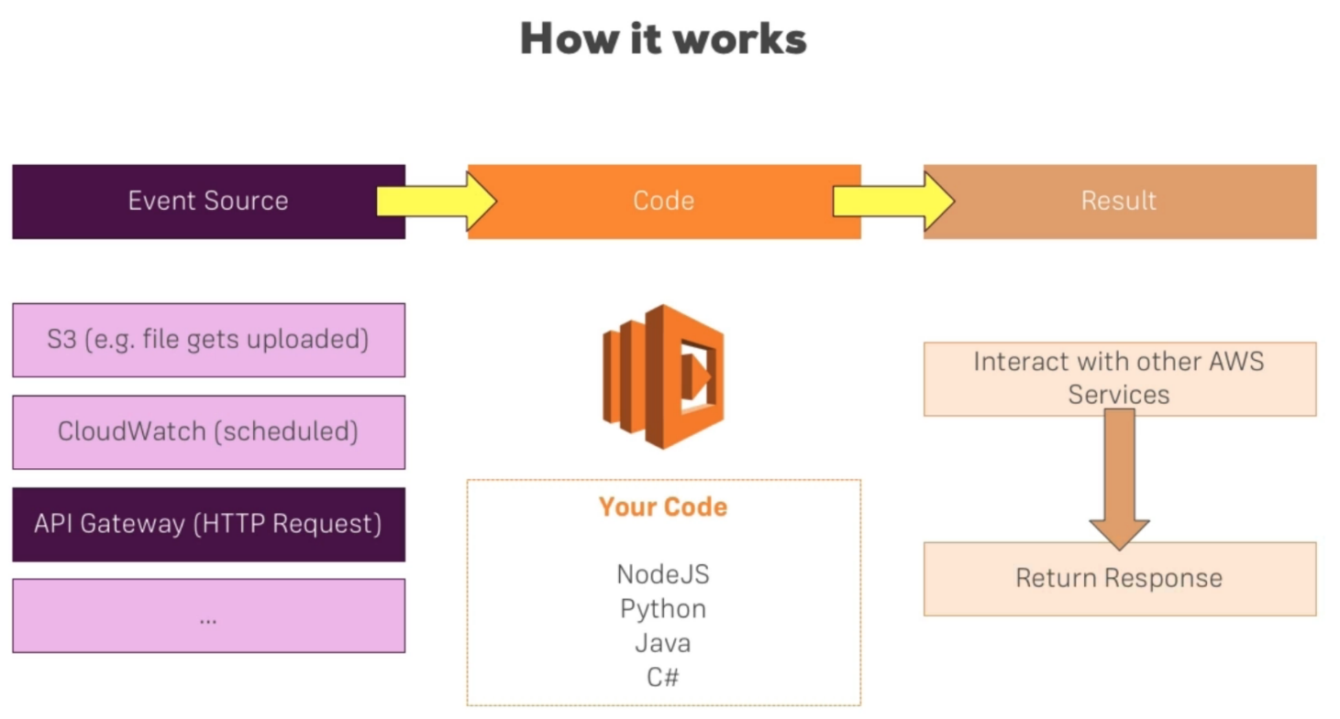AWS API Gateway + AWS Lambda 
POST [book 
GET /books 
DELETE /book/:id 
Lambda Function 
Lambda Function 
Lambda Function AWS Lambda is a serverless compute service that lets you run code without provisioning or managing 
servers, creating workload-aware cluster scaling logic, maintaining event integrations, or managing 
runtimes. With Lambda, you can run code for virtually any type of application or backend service - all with 
zero administration. Just upload your code as a ZIP file or container image, and Lambda automatically and 
precisely allocates compute execution power and runs your code based on the incoming request or event, 
for any scale of traffc. You can set up your code to automatically trigger from over 200 AWS services and 
SaaS applications or call it directly from any web or mobile app. You can write Lambda functions in your 
favorite language (Node.js, Python, Go, Java, and more) and use both serverless and container tools, such 
as AWS SAM or Docker CLI, to build, test, and deploy your functions. 

**Benefits**

No servers to manage 
AWS Lambda automatically runs your code 
without requiring you to provision or 
manage infrastructure. Just write the code 
and upload it to Lambda either as a ZIP file 
or container image. 
Continuous scaling 
AWS Lambda automatically scales your 
application by running code in response to 
each event. Your code runs in parallel and 
processes each trigger individually, scaling 
precisely with the size of the workload, 
from a few requests per day, to hundreds of 
thousands per second. 

fetch - get method (mock)

store - post method (lambda)

Cost optimized with millisecond 
metering 
With AWS Lambda, you only pay for the 
compute time you consume, so you're never 
paying for over-provisioned infrastructure. 
You are charged for every millisecond your 
code executes and the number of times 
your code is triggered. With Compute 
Savings Plan, you can additionally save up 
to 17%. 
Consistent performance at any 
scale 
With AWS Lambda, you can optimize your 
code execution time by choosing the right 
memory size for your function. You can also 
keep your functions initialized and hyper- 
ready to respond within double digit 
milliseconds by enabling Provisioned 
Concurrency. 